Working in the Cloud

with ClearMedia Academy

ClearMedia WG FireboxV deployment

**Disclaimer**:

By using the ClearMedia vCloud Director templates, you can greatly reduce the amount of time needed to deploy new VMs. These templates have been configured with the best practices in mind, to assure optimal stability and performance. Although use of the template is not compulsory, it is recommended!

This guide assumes you are building a new vApp based on Template version 1.5 and deploying the template from the “Catalog” tab with a single server setup. This document covers connecting the new vApp to the internet via a basic Watchguard FireboxV virtual firewall appliance.

In-Depth explanation and step-by-step procedures

* We assume that you have started with the “How-To 1 VMware Template 1.6” Document.
* Request a Watchguard FireboxV feature key for your setup. Mention the customer name or contract. You can only request this for an active contract (activated quote). If the quote is not activated yet, do this first.
* Also request a public IP for the NAT IP you will find later on.
* Go to your vApp.
* Shutdown the vApp by pressing the red stop button under the tab vApp Diagram. Adding/deleting/changing networks requires that the vApp be in a shutdown state.

Afbeelding met schermafbeelding

Beschrijving is gegenereerd met zeer hoge betrouwbaarheid

* Go to the “Networking” tab.
* Right click on the name “vAppNet-Template”, choose “Properties” and change the “Network name” under the tab “General”. Start with “vAppNet-<customername>“. Click OK.

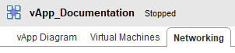

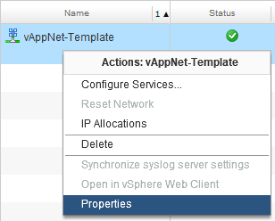 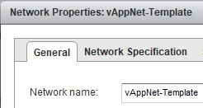

* Click on “Apply”.
* Add the Watchguard FBV template via the “Virtual Machines” tab.
  + Click on the Green Plus sign.

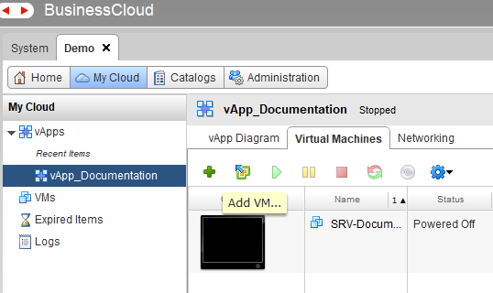

* + Make sure you are looking in the “Public Catalogs”.
  + On the “Add Virtual Machine” wizard, tick the box on the right for “Description”. This will give you extra information about the pre-provisioned inside network.

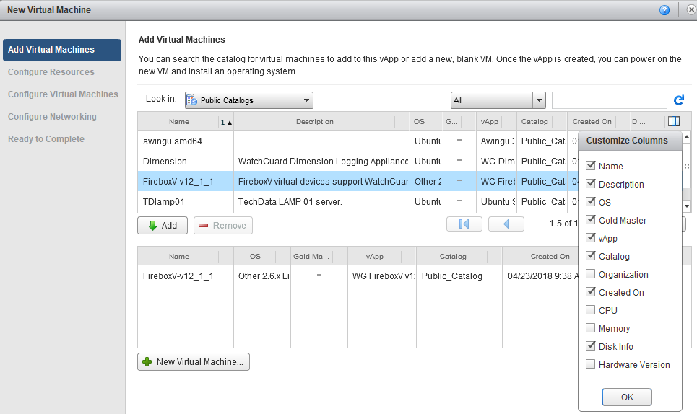

* + Click Add, then next.
  + Give it a unique name, starting with FireboxV. For example: FireboxV-Documentation.
  + Tick the box “Show network adapter type” and verify only **VMXNET 3** is used. 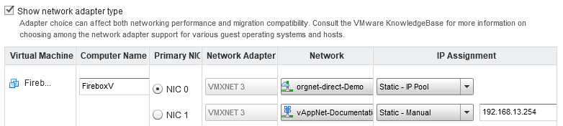
  + For the external network (uplink to internet), change the NIC 0 interface to orgNet-Direct-<OrgName> via the dropdown menu.
  + Leave the IP Assignment to “Static IP Pool” unless you already have a NAT IP in mind.
  + Connect the NIC 1 adapter to the internal vAppnet-<vAppname> network. Change the IP assignment to “Static – Manual” and give it 192.168.13.254 as the IP.
  + Press Finish.
* It will only take a few minutes to deploy the Watchguard FireboxV.
* While waiting find the NAT Subnet, Default gateway and IP Pool list for your Orgnet-direct.
  + Go to the Administration tab.
  + Open one of your vDC’s.
  + Open the “Org VDC networks” tab, and find you Orgnet-direct in the list with your Default Gateway address and Subnet Mask.

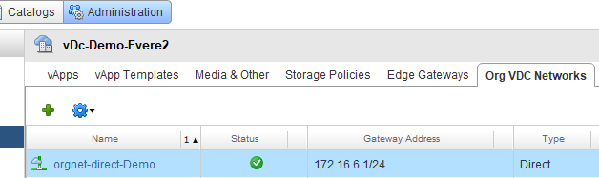

* Start the FireboxV and at least one VM by right clicking on it and pressing “Power On”
* While waiting, find the NAT IP for your vApp under the Virtual Machines tab, at NIC 0 of the FireboxV device and note it down. You will need it later on for your request to ClearMedia.

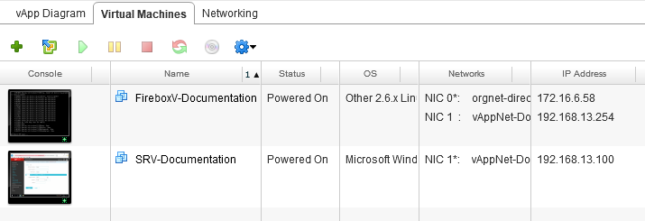

* On the Windows VM you will notice a yellow “Network indicator” symbol, indicating there is no internet connection. That is correct since the Watchguard needs to be configured.
* Open the Windows console using the “How-To VM Console” document, login on the server and open a browser.
* Open the WatchGuard admin Web interface via <https://192.168.13.1:8080>
* Ignore any security warnings about the Self Signed SSL certificate.

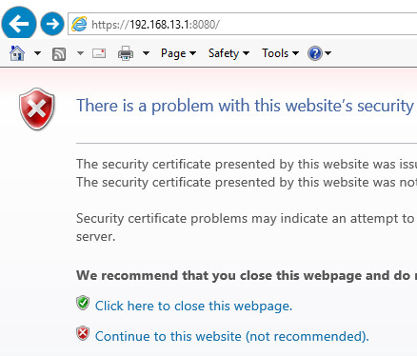

* Login with credentials “admin” and password “readwrite”.
* Open the tab “Network” and subtab “Interfaces”, click on the External interface and choose “Edit”.
* On the IPv4 tab, change the “Configuration Mode” to Static IP and enter IP address and Gateway

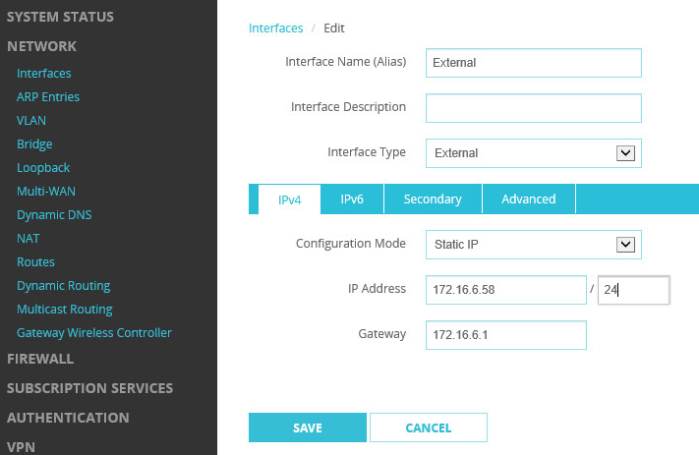

* For the External IP address you must use the same IP that you have found on the NIC0 interface of the WatchGuard FireboxV. For Gateway address, use the 172.16.x.x address.
* For extra public IP’s, you can add extra NAT IP’s under the “Secondary” tab. However, **NEVER** use a NAT IP out of the “Static Pool”. **Always** use NAT IP’s outside of the “Static Pool” for secondary IP’s. You noted this pool down during the step on de administration tab.
* Do not forget to click on the “**Save**” button.
* On the top, click on the banner that says “Add a feature key”.
* In the wizard, click on “Yes, I have a local copy of the feature key”

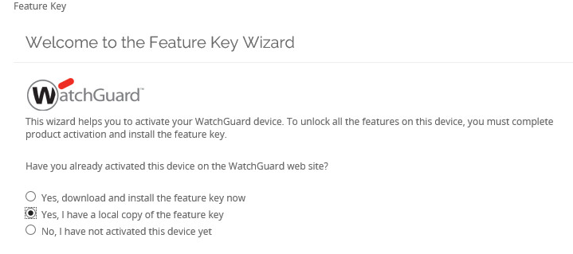

* Paste the entire feature key in the input box that you received from ClearMedia Support.
* Verify alarm notification is turned **OFF** and that Automatic feature key sync is turned **ON.**

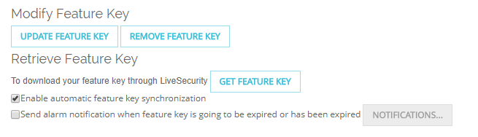

* **Communicate the NAT IP for the vApp (172.16.x.x) to ClearMedia support so we can link it to a public WAN IP. Otherwise incoming internet traffic will not be possible.**
* Open the server again and Sync the iNSTALL folder with the ClearMedia GitHub site by right clicking on C:\iNSTALL\SyncGit.ps1 and clicking “Run with Powershell”.
* Use the ClearMedia provided BG Info script, under C:\iNSTALL\BGInfo\PresetAndBgInfo – Shortcut to verify that the correct public IP is used.
* Remember: WebUI access from external is disabled by default. You must configure the firewall rule first, to allow remote access to the Watchguard Web Mgmt Interface.
* You should also reboot the Windows Server behind the Watchguard so it can activate the Windows license correctly.
* **Finished!**